# Problem 1.1

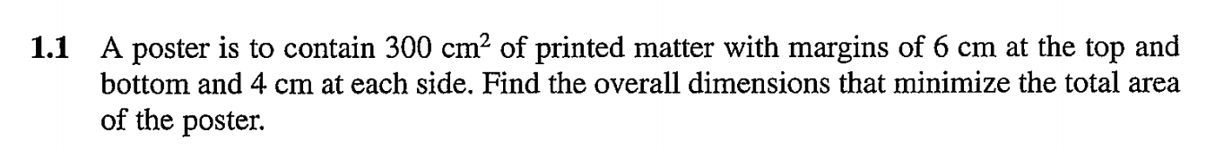

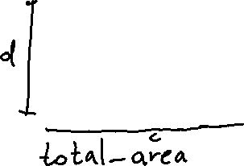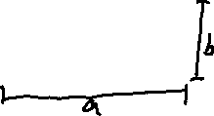

# Problem 1.2



# Problem 1.3



# Problem 1.4

# Problem 1.5



# Problem 1.8

# Problem 1.13

1. Temperature (T) is the independent variable because every other value changes when the temperature is changed. Optionally A or B can be chosen as the independent variable.
2. A and B are dependent variables if they are not chosen as independent.
3. Equality constraints are change of A and change of B. Initial values of A and B are not constraints here.
4. Temperature has an inequality constraint; it must be less or equal to 282℉.
5. To solve this, you need to use numeric integration to find the objective function. Then use an optimization tool to find the maximum.

# Problem 3.12

# Problem 3.13



